|  |  |  |  |
| --- | --- | --- | --- |
| **ID** | UC1 | **Usecase name** | Customer Statistic |
| **Author** | Nguyen Xuan Dinh | **Updater** | Nguyen Xuan Dinh |
| **Create day** | 02/12/2023 | **Update day** | 02/12/2023 |
| **Description** | The function starts when management wants to view and compile customer information | | |
| **Actor** | Manager | | |
| **Assumption** | After user login system | | |
| **Scenario** | **Bước 1:**  Sau khi đăng nhập , người dùng chọn mục khách hàng  **Bước 2:** Người dùng nhấn vào nút “thống kê “.  **Bước 3:** Chọn chức năng thống kê theo ngày, tháng, năm.  **Bước 4:** Hệ thống sẽ hiển thị toàn bộ danh sách theo yêu cầu. | | |
| **The customization** |  | | |
| **Non-functional requirement** | **Performance** | | |
| **Note** |  | | |

|  |  |  |  |
| --- | --- | --- | --- |
| **ID** | UC2 | **Usecase name** | Promotion design |
| **Author** | Nguyen Xuan Dinh | **Updater** | Nguyen Xuan Dinh |
| **Create day** | 02/12/2023 | **Update day** | 02/12/2023 |
| **Description** | The function begins when investors or management have a need to create promotions for business purposes. Promotions are usually applied to products or orders. | | |
| **Actor** | Manager | | |
| **Assumption** | After user login system | | |
| **Scenario** | **Bước 1:**  In the promotion interface, click on create promotion function  **Bước 2:** Choose the suitable product to create promotion  **Bước 3:**  Enter | | |
| **The customization** |  | | |
| **Non-functional requirement** | **Performance** | | |
| **Note** |  | | |

|  |  |  |  |
| --- | --- | --- | --- |
| **ID** | UC2 | **Usecase name** | Apply promtion |
| **Author** | Nguyen Xuan Dinh | **Updater** | Nguyen Xuan Dinh |
| **Create day** | 02/12/2023 | **Update day** | 02/12/2023 |
| **Description** | The function starts when a customer wants to use supermarket promotions. | | |
| **Actor** | Customers | | |
| **Assumption** | After users are in payment progress. | | |
| **Scenario** | **Bước 1:**  Click on Voucher button.  **Bước 2:** The list suitable voucher will display.  **Bước 3:**  User choose only one voucher  **Bước 4:** Click Apply button | | |
| **The customization** |  | | |
| **Non-functional requirement** | **Performance** | | |
| **Note** |  | | |

|  |  |  |  |
| --- | --- | --- | --- |
| **ID** | UC2 | **Usecase name** | Orders |
| **Author** | Nguyen Xuan Dinh | **Updater** | Nguyen Xuan Dinh |
| **Create day** | 02/12/2023 | **Update day** | 02/12/2023 |
| **Description** | The function starts when a customer wants to place an order. | | |
| **Actor** | Customers | | |
| **Assumption** | After users are in payment progress. | | |
| **Scenario** | **Step 1:** Select products already in the cart.  **Step 2:** Click the "Order" button.  **Step 3:** Complete the requirements during payment.  **Step 4:** Click "Confirm order" | | |
| **The customization** |  | | |
| **Non-functional requirement** | **Performance** | | |
| **Note** |  | | |

## **Sơ đồ usecase**

### **Sơ đồ usecase đăng nhập.**

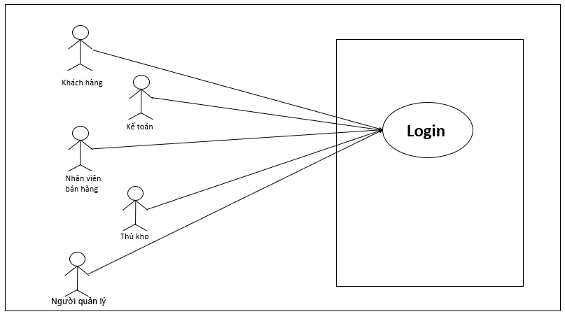

### **Sơ đồ usecase cho khách hàng.**

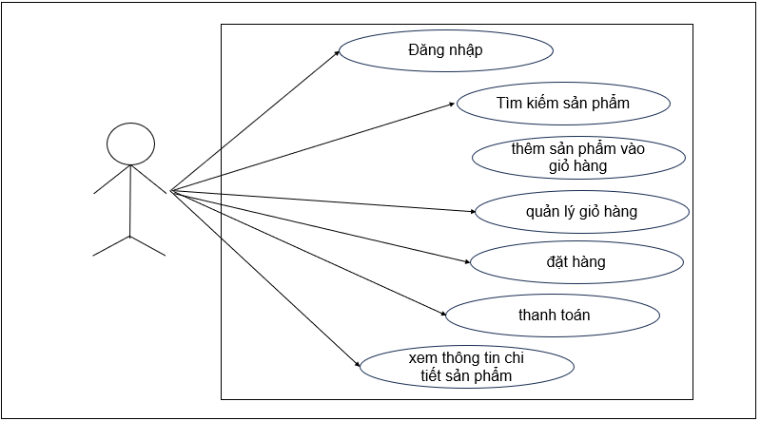

### **Sơ đồ usecase cho kế toán.**

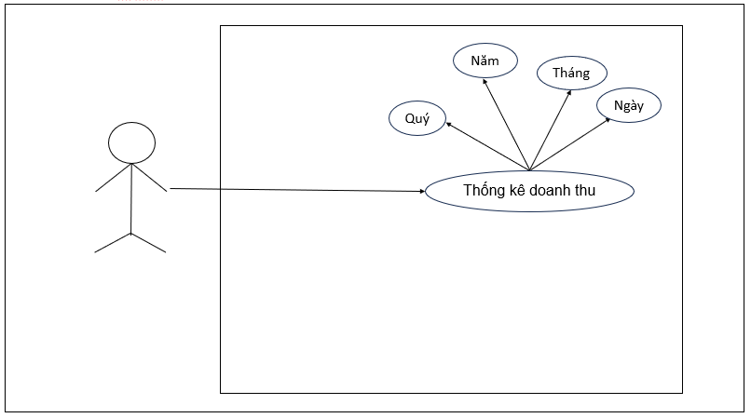

### **Sơ đồ usecase cho nhân viên.**

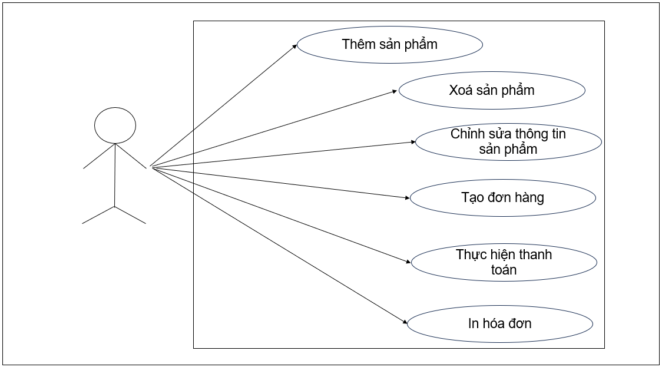

### **Sơ đồ usecase cho thủ kho.**

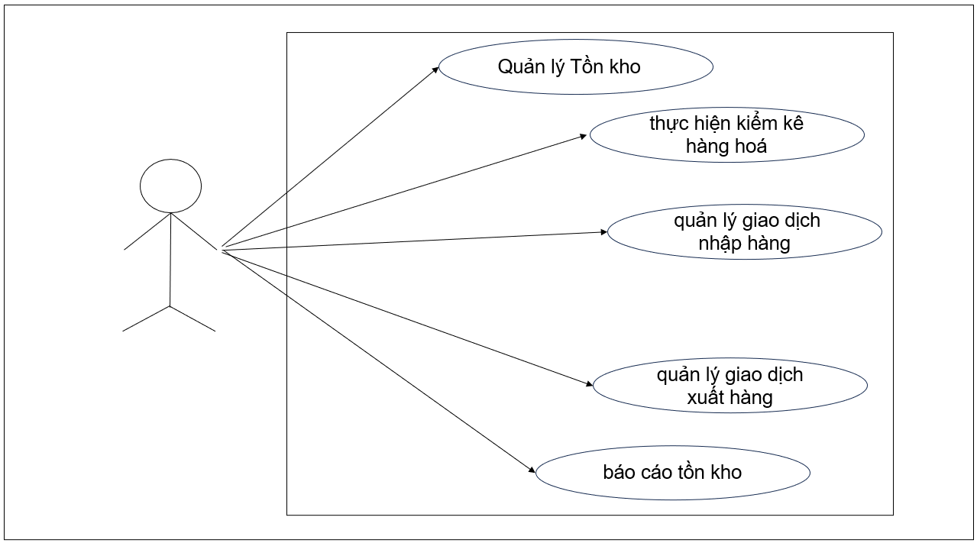

### **Sơ đồ usecase cho quản lý**

